Leon Carter Price
2/29/2020

Task 6: Animation Images
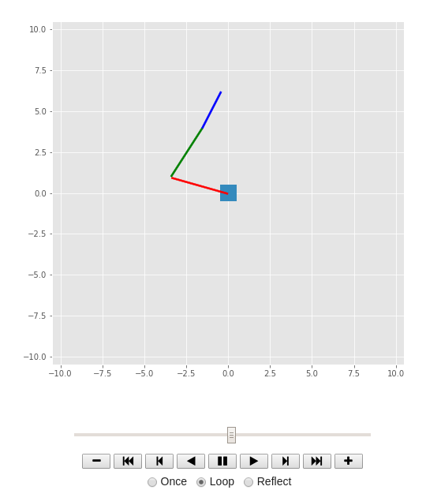
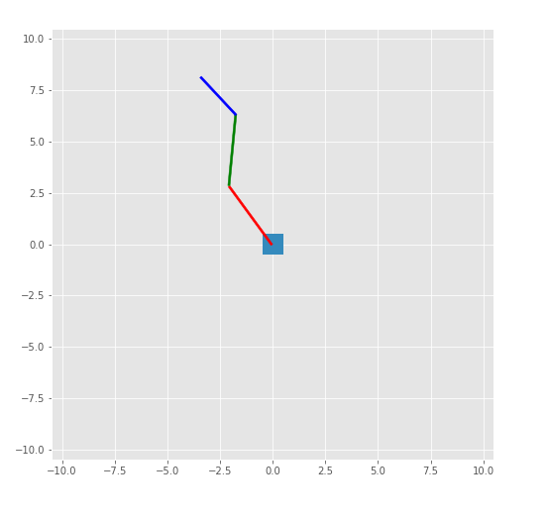

Task 7 write up for animate function

An instance of the 3 link arm is instantiated. Then the initial joint angles of the arm are declared. The initial forward kinematics are calculated. A goal position is declared. Then a trajectory is generated between the current location and the goal loacation. The animate function has 3 global variables declared pose, arm, q. first the forward kinematics are calculated for the joint angles q
Then the error between the current pose and the current iteration desired trajectory pose is calculated.
Then the jacobian of the arm is clculated.

Then in line that contains "q += np.dot(np.linalg.inv(J), error)" this multiplies the inverse of the jacobian by the error. So it takes the error in the task space and multiplies it by the inverse Jacobian to calculate the error in the joint space. The joint space errors are then added to the current joint values to move the arm closer to the desired location.

Then define the animation plotting.
This consists of getting the locations fo the links based on the current joint angles. Use the Poses to define their transnational and rotational motion in the animation. Define the starting pose sXl1, then the movements for the pose from starting to link 2 stL2. Next do the same for the next 2 links and use this for the animation display.

Bonus Question Images:
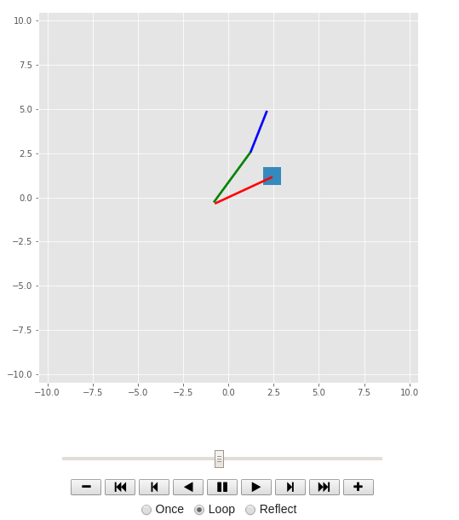
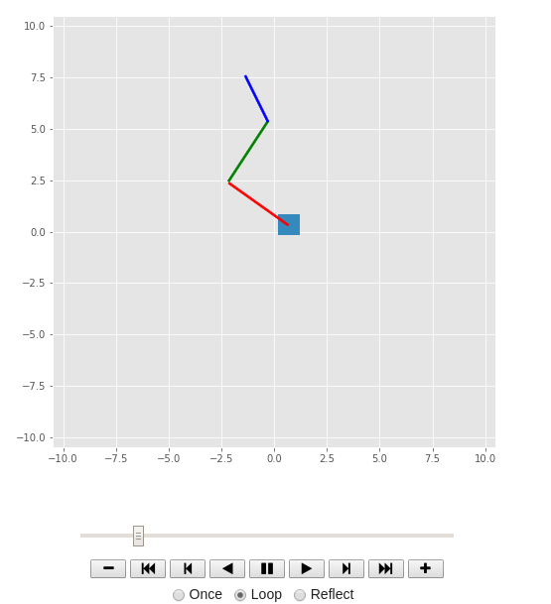
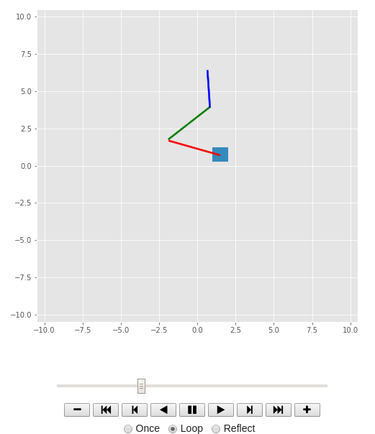
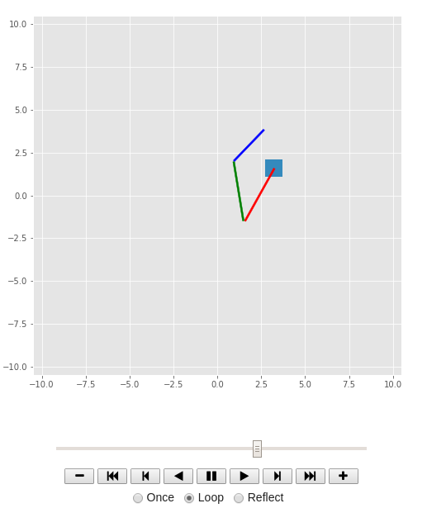
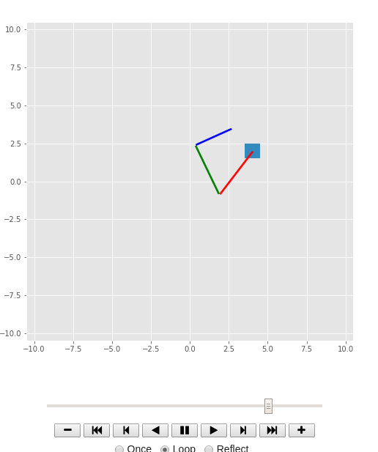
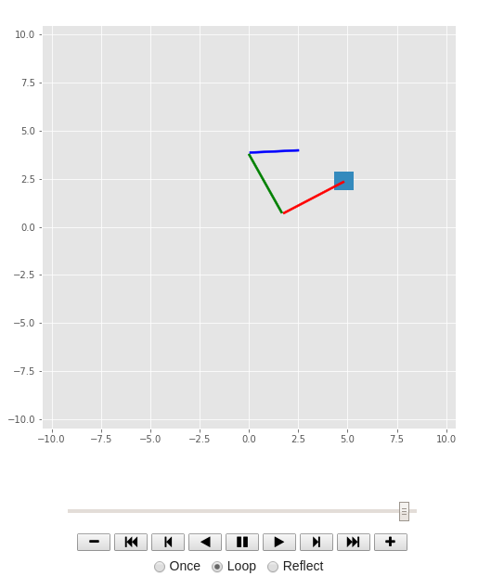

Co-Lab link: https://colab.research.google.com/drive/1J34tJp9VoR-JYCVW-J9-ukfZ3iNGVdnM#scrollTo=otQfsqfcTdd8

